 & 
PARTS LIST
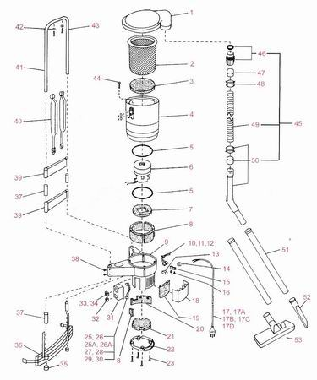

ITEM # | IMAGE | PART # | DESCRIPTION
1 |  | 806333 | Lid cannister
2 | 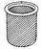 | 806253 | Filter Bag
3 |  | 805439 | Filter Secondary
4 | 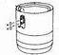 | 806262 | Cannister Upper Grey Assembly
 |  | 806163 | Cannister Upper Grey
 |  | 804922 | Clamp cannister lid (2)
 |  | 830035 | Rivet pop 73AS 4-4 Zn Pl (4)
 |  | 830026 | Washer 1/8 ID x 3/8 OD Zn Pl (4)
5 |  | 806497 | Sealing ring (2)
6 | 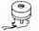 | 806160 | Motor 1000W 240V 50/60Hz
 |  | 805304 | Carbon brush motor 240V (2)
7 |  | 806101 | Insulation acoustic motor
8 |  | 806098 | Insulation acoustic fan case (4)
9 | 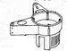 | 806145 | Cannister lower grey
10 |  | 806332 | Wire brown with thermostat
11 |  | 806107 | Wire blue 180mm
12 |  | 830054 | Cable tie CT 95M (2)
13 |  | 806108 | Terminal Lock
14 |  | 805695 | Bush strain relief 1147B
15 |  | 806141 | Cable clamp
16 |  | 805312 | Screw PT WN 1412 KB x 16Z (2)
17 |  | 806302 | Cord 0.25m 3 core red
17a |  | 803303 | Cord 18m 3 core Ext'n red
17d |  | 806169 | 3-pin round earth
18 |  | 806143 | Exhaust deflector grey
19 |  | 806097 | Filter exhaust
20 |  | 806100 | Insulation acoustic lower
21 |  | 806099 | Insulation acoustic lower end cap
22 |  | 806334 | Cap end
23 |  | 805283 | Screw PT WN 1412 KB 50 x 20Z (4)
25 |  | 806102 | Wire Brown 40mm
26 |  | 806103 | Wire Blue 40mm
31 |  | 806330 | Switch mounting plate 52S Grey
32 |  | 806329 | Switch mains 52S
33 |  | 806134 | Power outlet
34 |  | 806135 | Capacitor 0.22
35 |  | 806090 | Cap frame tube B123 (2)
36 | 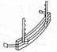 | 806341 | Strap padded waist grey
37 |  | 806335 | Tube red 20mm x 65 long (4)
38 |  | 830022 | Screw No. 8 x 3/8 PXR STS black (4)
39 | 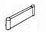 | 806340 | Strap padded back grey (2)
40 |  | 806339 | Strap padded shoulder grey (2)
41 | 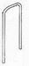 | 806338 | Frame tube
42 |  | 830120 | Washer 4.3 I.D. x 8.5 O.D. black nylon (2)
43 |  | 830118 | Screw No. 8 x 15 black streaker (2)
44 |  | 806267 | Screw PT WN 1411 KB 50 x 20Z (4)
45 |  | 806336 | Hose assy back pack 32mm  x 1.2 metres Grey
46 |  | 806349 | Tank fitting with seal
47 |  | 501807 | Screw cuff hull 32mm F.HE 15
48 |  | 501634 | Click Ring
49 |  | 806106 | Vacuum hose 32mm x 1.2 metre
50 | 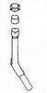 | 410509 | Bent hand wand with hull & ring
51 | 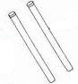 | 806117 | Chrome wand 32mm (2)
52 | 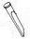 | 806133 | Crevice tool
53 | 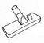 | 806254 | Combination floor tool W/W-D306
 |  |  | OPTIONAL TOOL ACCESSORIES
54 | 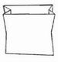 | 410117 | Pack (10) Paper Bags
55 | 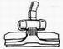 | 410580 | Floor tool with wheels-RD285
56 | 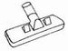 | 410427 | Combination floor tool W/W-RD272
57 | 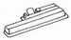 | 925046 | Powerhead PB4
58 | 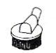 | 410559 | Dusting Brush
 |  |  | 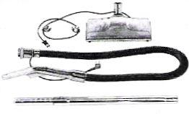
59 |  | 806337 | CME Electric brush kit
 |  | 806350 | Electric brush CME
 |  | 806351 | Telescopic Wand
 |  | 806352 | Hose Power cord Assy

